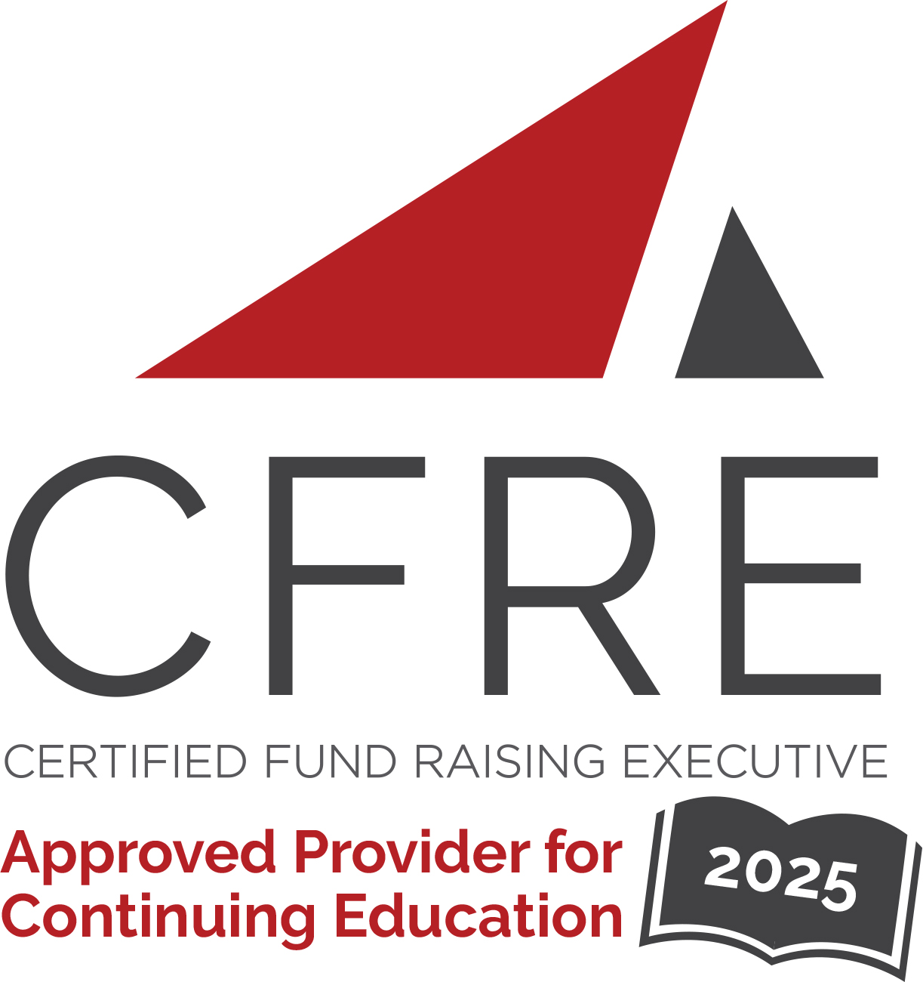  CFRE International has developed this form as a way for you to quickly track (and keep in your files!) the continuing education sessions you have attended. Simply check the boxes next to the sessions you attended. At the end of the conference, add up the total number of hours. Keep this sheet and you will be ready to complete your application form. All of the session slots listed are eligible for continuing education points on your CFRE application for initial certification and/or recertification. Sessions not listed here are not eligible for points. |  | CONTINUING EDUCATION POINTS TRACKER

Activity Organizer: - AFP Greater Philadelphia Chapter
Title of Activity: - Leading Philanthropy: Thought Leadership for Tomorrow’s Challenges
Names of Presenter(s): - Various
Dates and Location: - 17 September, 2025 – Drexel Hill, PA USA

Date: 17 September, 2025
Session 1: 9:00am – 10:00am (1 pt)
- Keynote Panel: Solving Our Challenges Through Philanthropy

Date: 17 September, 2025
Session 2: 10:15am – 11:15am (1 pt)
- From Curiosity to Commitment: Crafting the Right Message for the Right Moment
- Adapting to Unprecedented Times
- Valley Youth House
- Strengthening Relationships to Increase Your Grant Success
- Built to Last: Burnout Prevention for High-Stakes Fundraising

Date: 17 September, 2025
Session 3: 11:30am – 12:30pm (1 pt)
- From “No” to “Now:” Five Ways to Reignite Your Major Gift Momentum
- A Tale of Two Campaigns, and how the One that Failed Led us to Success Years Later
- From Mission to Mailbox: Direct Mail to the Rescue!
- Loving the Call: Building Donor Engagement Strategies that Create Fulfillment
- Leading Your Team in the Current Climate

Date: 17 September, 2025
Session 4: 1:30pm – 2:30pm (1 pt)
- Leading Your Team into the AI Era
- One Plus One Equals WE
- Soliciting + Closing Major Gifts (Through a Campaign Lens and Otherwise)
- The Art and Science of Relationship Building
- Planned Giving: More Than a Gift

Date: 17 September, 2025
Session 5: 2:45pm – 3:45pm (1 pt)
- Team First: The Art of Staff Stewardship
- Everybody Wins: Authentic, Aligned, and Collaborative Fundraising in Your Team
- Ctrl+Alt+Restore: A Burnout Recovery Session for Grant Pros
- The Metrics You’re Missing: Building Reports That Actually Drive Change
- Resilient Donor Stewardship: Creating a Development Operations Contingency Plan

Total number of points attained: __________

